“REJECTED ENERGY” THE REAL CULPRIT BEHIND
CLIMATE CHANGE AND HOW TO STOP IT

Energy prices and oil demand could drop to levels not seen since the late 1960’s

By Thomas Quinn, Founder of E-Fuel Corporation
On September 4, 1882 Thomas Edison flipped the switch on the world’s first power grid system at the Pearl Street Station in the Financial District of Manhattan that was fired by coal with stacks spewing out hot air pollution. During this same period John D Rockefeller began producing kerosene and gasoline fuels, followed by Henry Ford’s first automobile production plant, and the Wright Brothers kickstarting the aviation industry. Most scientists would agree this era likely triggered our current major Climate Change condition. In the past twelve-years the U.S. and international investors and government-sponsored grants reportedly have spent $3.5 trillion on renewable type energy technologies to reverse Climate Change to no avail. The Climate Change panic has also caused energy poverty to rise placing the world at further risk to quickly find and implement the right solution.

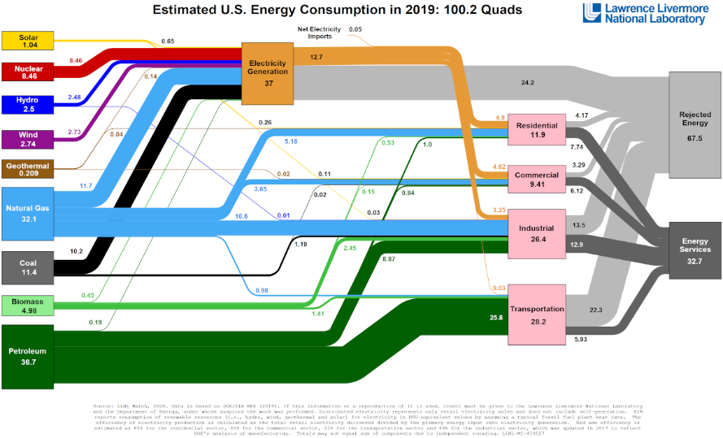
With my latest startup, E-Fuel Corporation, we aggressively pursued to identify the real Climate Change problem and implement the correct solution. During our research we came across the adjacent Lawrence Livermore National Laboratory and U.S. Department of Energy’s Energy Consumption Rate Chart that contained a disturbing category titled “Rejected Energy” which astonished us in two ways. First, the level in 2019 was listed as 67.5%, which is the subtotal percentage amount taken from the total 100.2 Quadrillion consumed but unused U.S. energy that was rejected along with carbon and greenhouse gases into the atmosphere. Second, the annual Rejected Energy rate has been increasing by 0.3% for the past 12 years which is substantially worse than other reported Climate Change science data.
REJECTED
ENERGY
67.5%

To put this in simple terms, if you placed three gallons of fuel into your vehicle, only one gallon provides mechanical energy to rotate the wheels and the remaining two gallons are rejected through the radiator, tailpipe, and engine friction heat into the atmosphere. Even electric vehicles Reject Energy constantly during battery charge and discharge cycles which accelerates as the battery ages. Before someone says we should just quit using fuel, I would then tell them that is not possible because every commercial manufactured product on earth either directly or indirectly requires fuel, especially renewables, during the production process, and that is not going to change. Tragically, Rejected Energy is the largest untapped energy source on the planet that society has ignored. This egregious 138-year failure has damaged the planet’s biological community of interacting organisms and their physical environment which must be stopped!

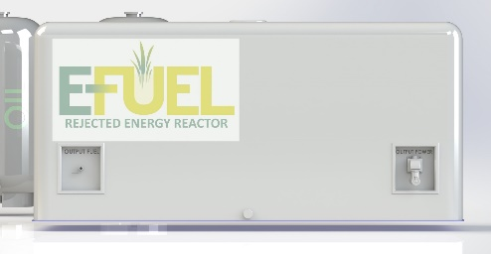
THE SOLUTION: E-Fuel has been able to solve the 138-year-old problem by creating a small reactor containing both fuel and power production processes in one system so that the rejected energy can be repurposed. In simple terms, now 3 gallons are used when running at full efficiency to produce both fuel and electrical power, which reduces past fuel consumption and emissions by two-thirds. E-Fuel believes this technology solution is the most aggressive and likely the only viable choice to reverse Climate Change along with energy poverty. Consumers and commercial businesses could benefit from a substantial reduction in energy prices not seen since the late 1960’s along with rapid decline in oil demand and abiotic strip mining of renewable energy materials.
Now that E-Fuel has provided the correct solution the bigger question becomes how we implement the paradigm-shift to begin cooling the planet. The answer is straightforward, capital and lots of it, over time in the order of $5 billion to begin phasing out central oil refineries, abiotic renewables, and power grid substations. Remember the world spent $3.5 trillion during the past twelve-years that increased Global Warming emissions by 0.3% per year which Einstein would have defined as insanity. It is time for world citizens to demand industries and governments change direction to reset the course towards repurposing Rejected Energy to correctly Stop Climate Change. We should expect the $5 trillion energy industry will put up a tremendous resistance on maintaining the status quo but that should not define our destiny.

E-Fuel’s first Proprietary reactors will focus on producing lower cost and lower carbon for power, ethanol, hydrogen, and kerosene jet fuel. Reactor size and energy capacities can adapt to serving a wide range of off-grid customers, such as individual homes, commercial buildings, data centers, microgrid distributed communities, fueling and charging stations, aerospace and aviation fuels, marine and ground freight transportation industry, agricultural processing centers, fulfillment distribution centers, and large manufacturing facilities.

To fund the production operations for E-Fuel Rejected Energy Reactor (RER), E-Fuel is investigating Special Purpose Acquisition Companies (SPAC), international environment-friendly partnerships and GoFundMe https://gofund.me/661ca5e2 to help finance production activities to quickly begin cooling the planet. Please visit our website at www.efuel100.com to learn more about supporting “STOP CLIMATE CHANGE”

